Image Knee-X-ray Enhancement

Original Image is shown in Figure 1.

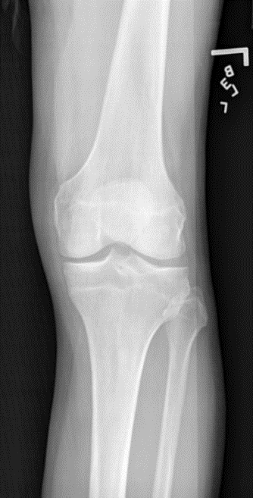

Figure 1. Original Image

Image Enhancement refer to remove the noise and muscle. In this case, in order to remove noise as well as muscle, I have try many times, then I found a methodology to get the result.

In this methodology, I have used 3 different techniques which is included: Image Contrast Enhancement, Image Subtraction in one image and Image Histogram Equalization.

Here is the algorithm of this methodology

Input: Original X-ray Image.

Step 1: Histogram the original image without using histeg() function.

Step 2: Subtraction the constant of image with the value 200.

Step 3: Histogram the subtraction image without using histeg() function.

Step 4: Subtraction the constant of image again with value 100.

Step 5: Contrast the image.

The following detailed will be shown the image and coding of each step:

Step 1:

Coding of Matlab was written in FirstHis.m script

I=imread('OA2.png');

numofpixels=size(I,1)*size(I,2);

HIm=uint8(zeros(size(I,1),size(I,2)));

freq=zeros(256,1);

probf=zeros(256,1);

probc=zeros(256,1);

cum=zeros(256,1);

output=zeros(256,1);

%freq counts the occurrence of each pixel value.

%The probability of each occurrence is calculated by probf.

for i=1:size(I,1)

for j=1:size(I,2)

value=I(i,j);

freq(value+1)=freq(value+1)+1;

probf(value+1)=freq(value+1)/numofpixels;

end

end

sum=0;

no_bins=255;

%The cumulative distribution probability is calculated.

for i=1:size(probf)

sum=sum+freq(i);

cum(i)=sum;

probc(i)=cum(i)/numofpixels;

output(i)=round(probc(i)*no_bins);

end

for i=1:size(I,1)

for j=1:size(I,2)

HIm(i,j)=output(I(i,j)+1);

end

end

figure,imshow(HIm);

title('First Histogram equalization');

ouput: Image

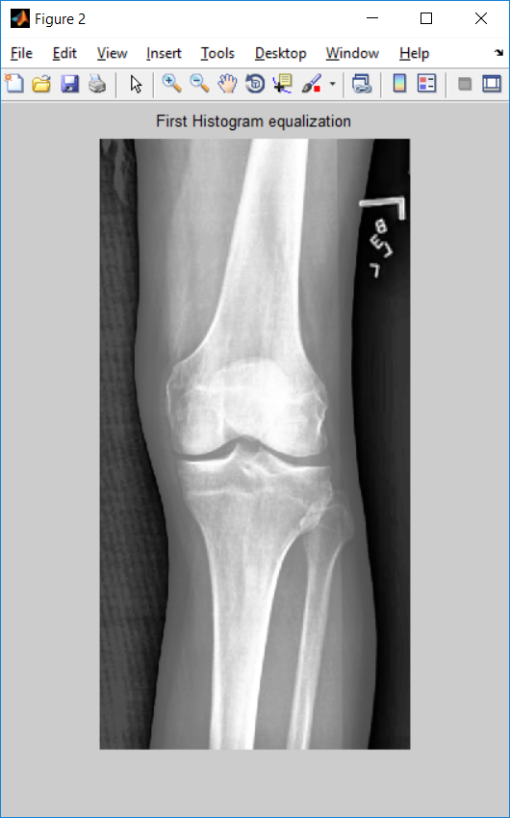

Step 2: Subtract image constant within value 200:

J = imsubtract(HIm,200);

figure,imshow(J);

title('First Subtract 200');

Output: Image

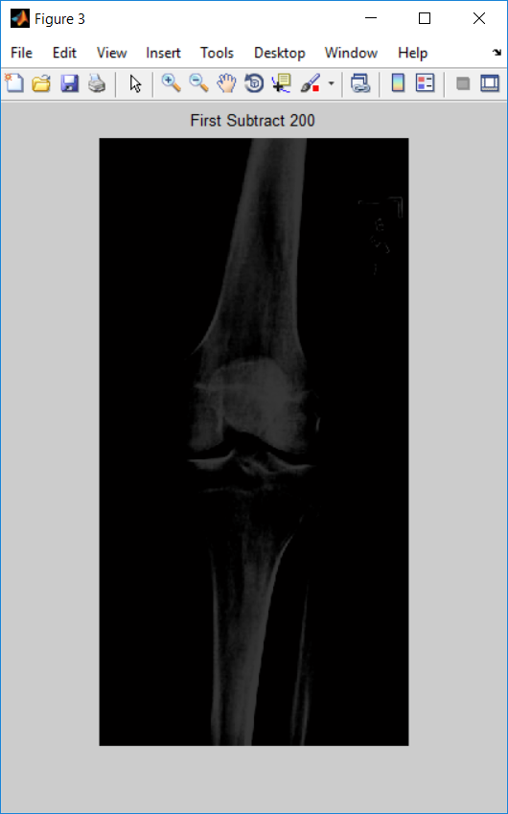

Step 3: Histogram the subtraction Image again.  
Code was writing in the scrip SecondHis:

numofpixels=size(J,1)*size(J,2);

HIm=uint8(zeros(size(J,1),size(J,2)));

freq=zeros(256,1);

probf=zeros(256,1);

probc=zeros(256,1);

cum=zeros(256,1);

output=zeros(256,1);

%freq counts the occurrence of each pixel value.

%The probability of each occurrence is calculated by probf.

for i=1:size(J,1)

for j=1:size(J,2)

value=J(i,j);

freq(value+1)=freq(value+1)+1;

probf(value+1)=freq(value+1)/numofpixels;

end

end

sum=0;

no_bins=255;

%The cumulative distribution probability is calculated.

for i=1:size(probf)

sum=sum+freq(i);

cum(i)=sum;

probc(i)=cum(i)/numofpixels;

output(i)=round(probc(i)*no_bins);

end

for i=1:size(J,1)

for j=1:size(J,2)

HIm(i,j)=output(J(i,j)+1);

end

end

figure,imshow(HIm);

title('Second Histogram equalization');

Output: image

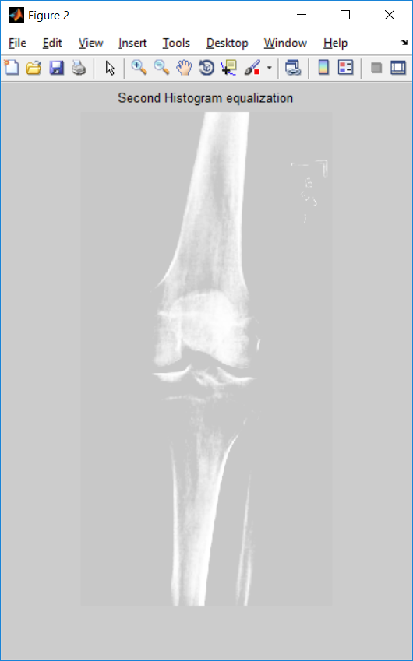

Step 4: Subtract again with constant value 100

Coding:

J1 = imsubtract(HIm,100);

figure,imshow(J1);

title('Second Subtract 100');

Output: Image

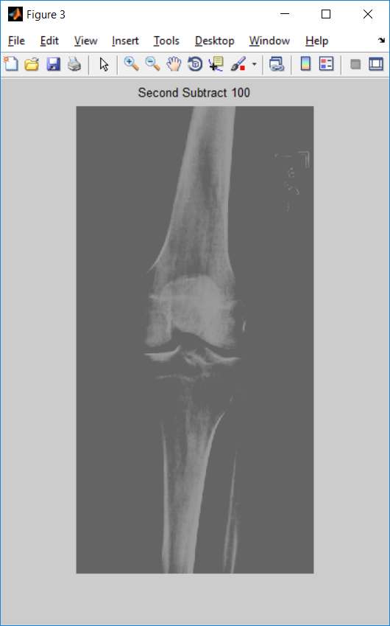

Final step:

Step 5: Contrast the image

contr =imadjust(J1, [0.01 0.1], []);

figure,imshow(contr);

title('Image Enhancement Remove Muscle');

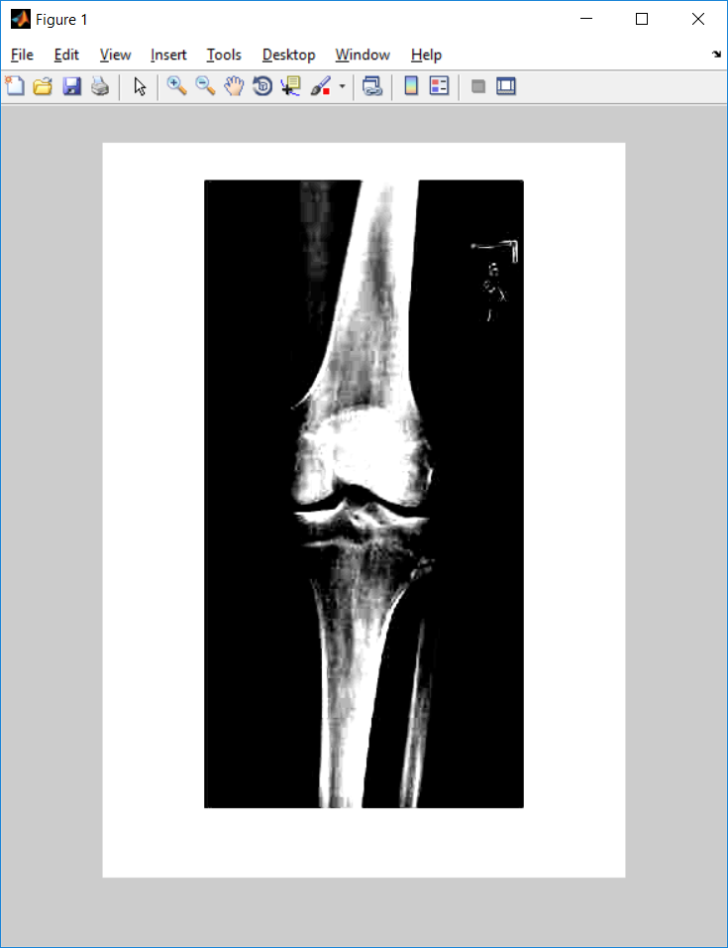

Figure 2. Image after Enhancement.